UNIT: 8

**Organizational Culture :** Meaning, Strong Culture vs. Weak Culture, Creating & sustaining Culture, Socialization

Culture is the set of important understandings that of a community share in common. It consists of patterns and ways of thinking, feeling, and reactions that are acquired by language and symbols that create distinctiveness among human group.

Culture of the organization plays an important role in the area of motivation and the level of economic rewards. It also influences the level of commitment to work on the part of the members. Organizational culture represents a common perception shared by the member of an organization and has a tendency to describe the organizational culture in almost similar terms.

*Everything you need to know about organizational culture. The term*

*‘Organizational Culture’ refers to the norms and values of an organization, which together make the personality of the company.*

*Improving organizational culture is the need of the hour, as people want to work for a company that enables them to maintain a balance between their work/professional life and personal life and organizations who give importance to organizational culture increase their productivity and lower are the attrition rates.*

*So, a healthy organizational culture is a win-win situation for all the stakeholders, shareholders, management, customers and employees.*

Culture is training, development and refinement of mind, tastes and manners- the condition of being thus trained and refined.

Culture is the act of developing intellectual and moral faculties, especially through education. Culture is the moral, social and behavioural norms of an organization based on the beliefs, attitudes and priorities.

Culture drives the organization and its actions. It is somewhat like, “the operating systems” of the organization.

It guides how employee think, act and feel. It is dynamic and fluid and it is never static.

A culture may be effective at one time under a given set of circumstances and ineffective at another at another time.

Culture of an organization operates at both a conscious and unconscious level. Some aspects of culture are visible and tangible and others are intangible and unconscious. Avoidance of conflict is a value that is an excellent example of an unconscious norm.

Organizational culture is quite complex. Every company has its own unique personality, just like people do. The unique personality of an organization is referred to as its culture.

Organizational culture/corporate culture includes-

* The ways the organization conducts its business, treats its employees, customers, and the wider community,
* The extent to which freedom is allowed in decision making, developing new ideas, and personal expression,
* How power and information flow through its hierarchy, and
* How committed employees are towards collective objectives.

**These different cultural concepts include:**

**1. Dominant Culture:**

Most of the employees of Videsh Sanchar Nigam Limited (VSNL) believe that the business strategies of the company are not aggressive compared to those of the private sector. This core shared belief by most of the employees is called dominant culture.

**Dominant culture, thus, denotes the core values which are shared by majority of the employees in the organisation. It is the macro-cultural perspective that presents the organisation’s personality.’**

**2. Sub-Cultures:**

HPCL started its own retail outlets. Managers and employees of these outlets have autonomy and freedom to operate. The shared value of the employees of the retail outlets is that they are allowed to be competitive.

Thus, sub-cultures are denoted by units/departments/geographic separations. They are mini- cultures within the company.

**Core Values:**

Employees in HPCL are not allowed to be competitive. It is the core value. Core values are primary or dominant values; those are accepted by the majority of the organizational members.

**3. Strong Cultures:**

The system of the public sector organisation does not allow the potential employees to be competitive. These values are intensely held and widely spread. Thus, the organisation’s core values which are intensely held and widely spread are called strong cultures.

Strong cultures have great influence on the employee behaviour. As such, most of the competent employees in the public sector are highly frustrated.

**4. Weak Cultures:**

In a weak culture, the organisation’s core values are lightly held and occasionally shared. For example, Indian Railways is more concerned towards its customers.

**5. Mechanistic and Organic Cultures:**

The most important aspects of organisation in public sector companies include hierarchies, supervision, control, formalisation, flow of authority and communication from top to bottom, etc., rather than the results or outcome. Organisations with these characters are termed as mechanistic organisations. They follow status quo strategy and therefore resist innovation and aggressiveness on the part of employees. These organisations also lack customer-orientation and employee welfare.

Tata Infotech, on the other hand, is more flexible and open. Jobs and roles are not defined rigidly and employees are given freedom to adjust themselves to the environmental requirements. Concern is more towards the outcome and results, but not the procedure or hierarchy.

Communication in this company is more multi-directional. The informal communication is widely used. Decision-making is more decentralised. People with the ability to handle problems are given freedom to assume authority and responsibility. This company is a continuous learning organisation from the environment and such companies are termed as organic structures.

The mechanic culture de-motivates the competent people and leads to negative organisational culture. Whilst the organic culture motivates the able employees to be competitive and innovative.

**Strong Culture vs. Weak Culture**

**Strong Culture**

The strength of a company’s organizational culture ultimately determines its success.

Strategically, changing an organization’s culture takes a determined and effective leader who unselfishly puts the organization first before self. A strong culture is one which is deeply embedded in the ways a business or organization does things.

With a strong culture, employees and management understand what is required of them and they will try to act in accordance with the core values.

A company with a strong culture provides clear expectations for employees about their jobs, behavior, and dress.

There should also be a clear cut chain of command. This type of atmosphere fosters a sense of wellbeing in employees and helps them to work towards the greater good of the company. The only danger of a strong organizational culture is a concept called “group think”.

This is a term coined by Irving Janis that occurs because a group thinks so similarly that they lose the ability to become innovative and make poor decisions. In a strong culture, the organization’s core values are both intensely held and widely shared.

A key benefit of a strong culture is that there is less need for detailed policies and procedures because the “way things are done around here” is well understood and accepted. There are many great examples of organizations with strong cultures.

Indeed, organizations built on a clearly defined set of core values, consistently applied, use their strong culture as a source of competitive advantage.

A strong organizational culture works like strong social glue, which bonds members of an organization together through shared goals. This builds loyalty and commitment among the group and makes them less likely to leave their tight-knit organization.

Although organizations with strong cultures experience fewer turnovers, it doesn’t mean that a strong culture is better than a weak culture in every instance. A strong culture is difficult to change in an organization and can stifle innovation because members of the organization are used to doing their jobs exactly the same way.

A strong culture exists when employees respond to stimulus because of their alignment to organizational values. Strong cultures help firms operate like well-oiled machines cruising along with outstanding execution. Minor tweaking of existing procedures enhances performance.

In thriving, profitable companies, employees embody the values, visions and strategic priorities of their company.

**Weak Culture**

A weak [**organizational culture**](https://www.iedunote.com/organizational-culture) is one in which employees are not clear with what their goals are. A weak culture is evident when most employees have varied opinions about the organization’s mission and values.

The company is disorganized and this requires extra efforts and time to attain maximal unity of purpose. Employees waste time spinning their wheels, because of the inability to focus on what’s important.

Weak organizational culture allows for an increase in turnover of employees because of a lack of corporate cohesiveness and mission. This spirals into low employee morale, and employee disengagement.

A key consequence of weak culture is that there is a greater need for procedures, policies, and bureaucracy, in order to get things done in the desired way, within the turn, can add substantially to organizational costs.

Weak cultures can be advantageous for organizations that benefit, from independent thought and innovation by their members. In an unstable environment, organizations with weak cultures often function better than organizations with strong cultures, because they are much more adaptable to change.

In order for an organization to succeed, the culture of that organization must fit the environment in which it operates.

Research indicates that the strongest cultures embrace the importance of Kaizen or continuous improvement. Kaizen cultures require both conscious and subconscious thinking about improvements from everyone.

Conversely, a weak culture exists when there is little alignment with organizational values and control must be exercised through extensive policies, procedures, and bureaucracy.

Signs of a weak culture include lack of trust; focus on problems, staff losing confidence in their leaders and systems, and people spending more time focusing on problems rather than opportunities.

**How to Keep the Culture Alive in your Organization?**

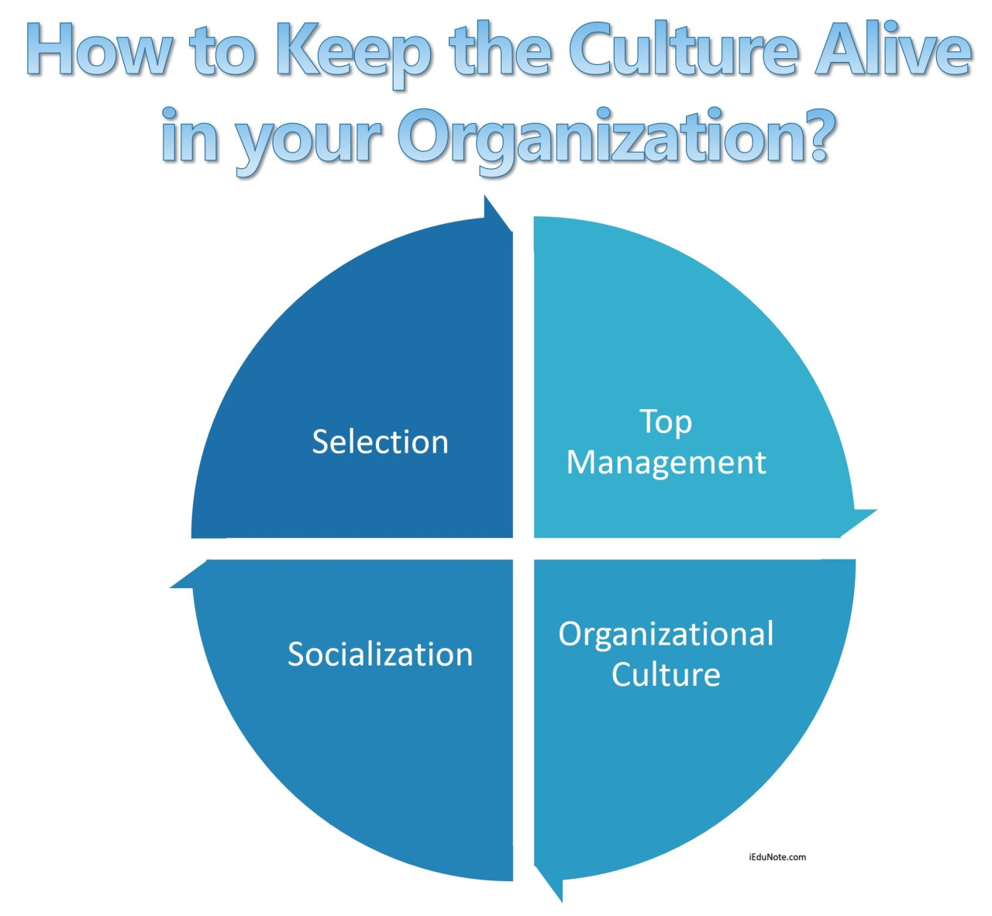

Once a culture is in place, there are practices within the organization that act to maintain it by giving employees a set of similar experiences.

Some important practices which help to sustain the culture strengthening organizational culture are as depicted in the following diagram:

**Selection**

The first such practice is the careful selection of candidates.

Standardized procedures should be used to hire the right people for the right jobs. Trained personnel interview the candidates and attempt to screen out those whose personal styles and values do not fit with the organization’s culture.

By identifying the candidates who can culturally match the organizational culture, selection helps sustain culture to a large extent.

Additionally, the selection process provides to the applicants, information about the organizational culture.

If the applicants perceive a conflict between their values and values of the organization, they can themselves decide not to join the organization.

**Top Management**

The [**actions of top management**](https://www.iedunote.com/management-levels-hierarchy) also have a major impact on the organization’s culture.

Through what they say, how do they behave senior executives establish norms that filter through the organization as to whether risk-taking is desirable, how much freedom managers should give to their subordinates, what is the appropriate dress code, what actions will pay off in terms of pay raise, promotions, and other rewards and the like.

**Socialization**

The organization may have done a very good job in the recruitment and selection of the employees, but sometimes the employees are still not indoctrinated in the organization’s culture.

Since these persons are not familiar with the organization’s culture they are most likely to disturb the existing beliefs and customs of the organization.

Therefore, it is very essential for the organization to help new employees adapt to its culture. This adaptation process is called ‘[**Socialization**](https://www.iedunote.com/organizational-socialization)’.

## 3 Stages of Organizational Socialization

3 stages /steps the socialization process in the organization;

1. The Pre-Arrival Stage.
2. The Encounter Stage.
3. Metamorphosis.

## The Pre-Arrival Stage

The socialization process contains three stages that occur consecutively. It starts with the pre-arrival stage, which consists of anything a potential organization member has learned about the organization prior to joining.

Part of the pre-arrival stage is the selection process, which is used by the hiring company to hire people who can adequately perform the job but also to select people who will fit well into the culture of the company. The selection process provides the organization with information about the candidate but also gives the job-seeker information about the organization.

Candidates who find that their personal values do not match the core values of the prospective company should disqualify themselves from the selection process at this time.

## The Encounter Stage

Once a candidate accepts a job offer, they enter the encounter stage.

This stage is where the expectations of the new employee meet the reality of the job. If the reality of the new job is different than what the new employee expected it to be, socialization methods are used to orient the new employee to the existing culture and to help them make sense of the culture of their new organization.

Some of the socialization methods that are used include stories, rituals, material symbols, and language.

The following diagram explains the socialization process in the organization:

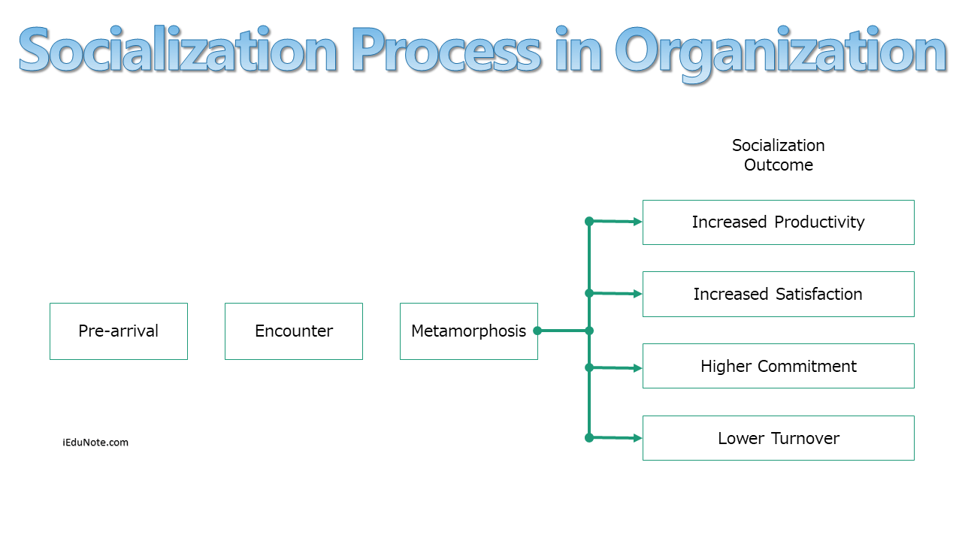

## Metamorphosis

Finally, the new member must work out any problems discovered during the encounter stage.

This may mean going through changes – hence, we call this metamorphosis stage. The options presented in the above figure are alternatives designed to bring about the desired metamorphosis.

Note that the more management relies on socialization programs that are formal, collective, fixed, serial, and emphasize divestiture, the greater the likelihood that newcomers’ differences and perspectives will be stripped away and replaced by standardized and predictable behaviors.

Careful selection by the management of newcomers’ socialization experiences can – at the extreme – create conformists who consider no organizational practice sacred.

Successful metamorphosis should have a positive impact on the new employee’s productivity and his commitment to the organization and reduce his propensity to leave the organization.